**Stage 3 Summary Report:**

1. Number of servers responded to ICMP ping requests:
   1. 7/10 servers responded with ICMP replies
2. Percentage of responsive servers (from part 1) with different IP-ID in ICMP Packets:
   1. Zero IP-ID counter = 0/7
   2. Incremental IP-ID counter = 7/7
   3. Random IP-ID counter = 0/7
3. Percentage of servers with port 80 open:
   1. 9 total servers out of the 10 have port 80 open
4. Percentage of responsive servers with different IP-ID in TCP Packets:
   1. Zero IP-ID counter = 6/9
   2. Incremental IP-ID counter = 2/9
   3. Random IP-ID counter = 1/9
   4. Server that got no tcp response back = 1
5. Percentage of responsive servers from part 3 that deploys SYN cookies:
   1. 5/9 servers deployed SYN cookies
      1. Total is out of 9 because only 9/10 servers have their port 80 open
6. Percentage of servers with Linux/Windows OS:
   1. Linux OS = 1/10 servers use Linux
   2. Windows OS = 6/10 servers use Windows

**Screenshots of All University Servers:**

1. [www.utoronto.ca](http://www.utoronto.ca)

1. [www.ubc.ca](http://www.ubc.ca)

1. [www.yorku.ca](http://www.yorku.ca)

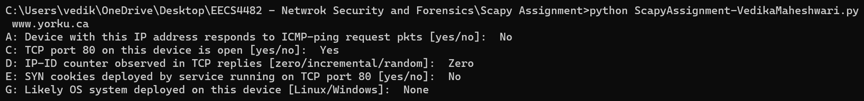

1. uwaterloo.ca

1. [www.uottawa.ca](http://www.uottawa.ca) A computer screen with white text

   Description automatically generated
2. [www.uwo.ca](http://www.uwo.ca)

1. [www.ualberta.ca](http://www.ualberta.ca)

1. [www.torontomu.ca](http://www.torontomu.ca)

1. [www.mcmaster.ca](http://www.mcmaster.ca)

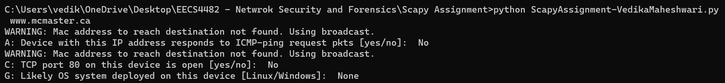

1. [www.ucalgary.ca](http://www.ucalgary.ca)

